Lab 19 – Code Translation: Converting Between Programming
Languages
Task 1 – Python to Java Conversion
Task:
Translate a simple Python class into Java using AI assistance.
Instructions:
• Prompt AI to convert a Python class with attributes and
methods into equivalent Java code.
• Verify that constructors, method signatures, and data types
are properly handled.
• Run both versions (Python &amp; Java) to compare expected
outputs.
PROMPT:
Convert the following Python class into equivalent Java code,including the ssttributes,constructor and methods.Ensure both programs produce the same output.
class Student:
def __init__(self, name, age, marks):
self.name = name
self.age = age
self.marks = marks

def display_details(self):
print("Student Name:", self.name)
print("Age:", self.age)
print("Marks:", self.marks)

def check_result(self):
if self.marks >= 40:
print("Result: Pass")
else:
print("Result: Fail")
# Creating an object
s1 = Student("Bouncy", 20, 100)
# Calling methods
s1.display_details()
s1.check_result()
JAVA CODE:
class Student {
private String name;
private int age;
private int marks;
public Student(String name, int age, int marks) {
this.name = name;
this.age = age;
this.marks = marks;
}

public void display_details() {
System.out.println("Student Name: " + name);
System.out.println("Age: " + age);
System.out.println("Marks: " + marks);
}

public void check_result() {
if (marks >= 40) {
System.out.println("Result: Pass");
} else {
System.out.println("Result: Fail");
}
}
public static void main(String[] args) {
Student s1 = new Student("Bouncy", 20, 100);
s1.display_details();
s1.check_result();
}
}
OUTPUT:
Student Name: Bouncy
Age:20
Marks:100
Result:Pass
PYTHON CODE OUTPUT:
Student Name: Bouncy
Age:20
Marks:100
Result:Pass
Comparison between Python and Java
Concept | Python | Java
1. Class | A class is created using the class keyword. | A class is created using the class keyword.
2. Constructor | Uses __init__() to initialize objects. | Uses a constructor with the same name as the class.
3. Variables | No need to declare the data type explicitly. | Data type must be declared explicitly.
4. Output | Uses print() to display output. | Uses System.out.println() to display output.
5. Object | Object is created by calling the class name. | Object is created using the new keyword.
6. Method | A method is defined using the def keyword. | A method is defined using a return type and method name.
RESULT:
Comparison between Python and Java
Concept Python Java
1. Class A class is created using the class keyword. A class is created using the class keyword.
2. Constructor Uses __init__() to initialize objects. Uses a constructor with the same name as the class.
3. Variables No need to declare the data type explicitly. Data type must be declared explicitly.
4. Output Uses print() to display output. Uses System.out.println() to display output.
5. Object Object is created by calling the class name. Object is created using the new keyword.
6. Method A method is defined using the def keyword. A method is defined using a return type and method name.
Task 2 – C++ to Python Function Conversion
Task:
Convert a C++ function for factorial calculation into Python.
Instructions:
• Ask AI to translate a recursive C++ factorial function into
Python.
• Validate correctness by testing with sample inputs.
• Ensure Python version follows Pythonic conventions.
PROMPT:
Convert the given recursive C++ factorial function into Python.
Use proper Python syntax and test it with sample inputs.
C++ CODE:
#include <iostream>
using namespace std;
int factorial(int n) {
if (n == 0 || n == 1) {
return 1;
}
return n * factorial(n - 1);
}

int main() {
int n = 5;
cout << "Factorial of " << n << " is " << factorial(n);
return 0;
}
C++ CODE OUTPUT :
Factorial of 5 is 120
PYTHON CODE:
def factorial(n):
if n == 0 or n == 1:
return 1
return n * factorial(n - 1)

# Sample tests
assert factorial(0) == 1
assert factorial(1) == 1
assert factorial(5) == 120
n = 5
print(f"Factorial of {n} is {factorial(n)}")
OUTPUT:
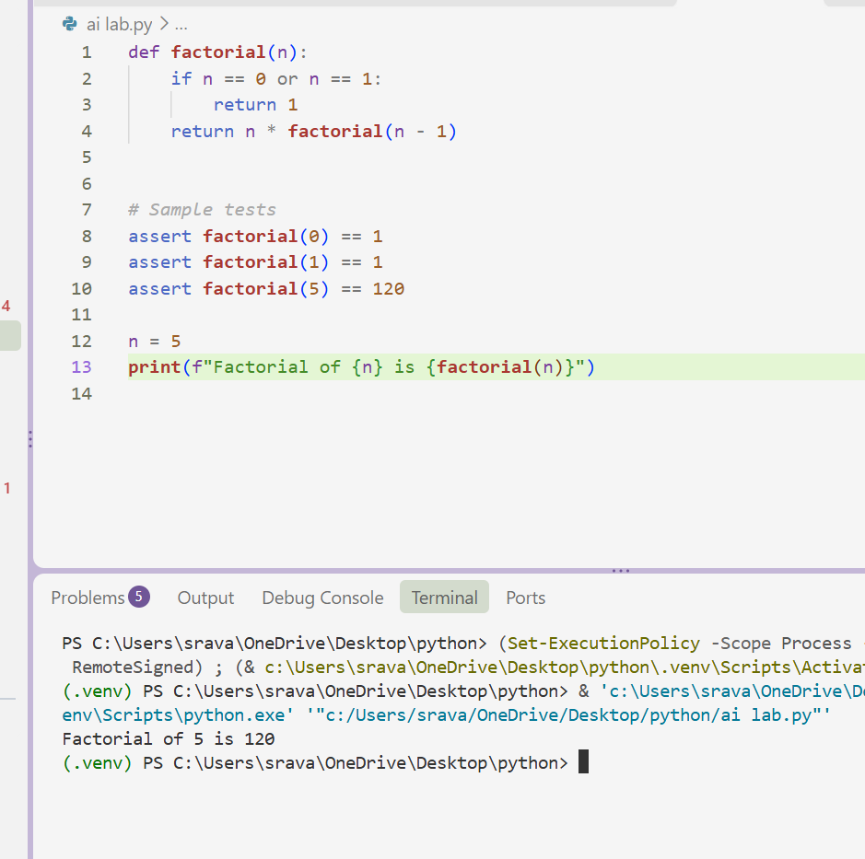
Important difference:
- C++: int has a limited range and can overflow for larger factorials.
- Python: Supports arbitrarily large integers (subject to available memory).
Conclusion: Both are correct, but Python is better for calculating large factorial values with this implementation.
Task 3 – SQL to Pandas Query
Task:
Translate a SQL query into a Pandas DataFrame operation in
Python.
Instructions:
• Provide AI with a SQL query (e.g., SELECT name, salary
FROM employees WHERE salary &gt; 50000).
• Ask AI to generate equivalent Pandas code.
• Test the generated code on a sample DataFrame.
Expected Output:
• Equivalent Pandas query that retrieves the correct subset of data.
PROMPT:
Convert the following SQL query into equivalent
Python Pandas code. Create a sample DataFrame
and display the filtered result.
SELECT name, salary
FROM employees
WHERE salary > 50000;
PYTHON PANDAS CODE:
import pandas as pd
# Create sample employee data
data = {
'name': ['Rahul', 'Priya', 'Arjun', 'Sneha', 'Kiran'],
'salary': [40000, 60000, 75000, 45000, 80000]
}
# Create DataFrame
employees = pd.DataFrame(data)
# Apply SQL equivalent using Pandas
result = employees[employees['salary'] > 50000][['name', 'salary']]
# Display result
print(result)
OUTPUT:
name salary
1 Priya 60000
2 Arjun 75000
4 Kiran 80000
SQL | Pandas
SELECT | Column selection
FROM | DataFrame
WHERE | Filtering
employees | employees DataFrame
Conclusion
The SQL query was successfully converted into an equivalent Pandas DataFrame operation. The Python program correctly filters employees with salaries greater than ₹50,000 and displays only their names and salaries.
Task 4 – Real-Time Application: Multi-Language Snippet Converter Scenario: Students will choose a real-time use case where they need code in multiple languages. Example: • Converting a Python web scraping snippet into JavaScript for browser automation. • Translating a Java method into C# for enterprise applications. Instructions: • Prompt AI to translate code between two chosen languages. • Test both implementations to ensure they produce the same results. • Document challenges faced during translation (e.g., syntax, libraries).
PROMPT:
Convert the following Python code into JavaScript.
Maintain the same logic and functionality.
Test both programs with sample inputs.
Python code:
a = 10
b = 20
result = a + b
print("Sum is:", result)
OUTPUT:
Sum is: 30
JAVA SCRIPT CODE:
let a = 10;
let b = 20;

let result = a + b;
console.log("Sum is:", result);
JavaScript Output:
Sum is: 30
Challenges Faced During Translation
- Syntax differences: Python uses indentation, whereas JavaScript uses curly braces for code blocks.
- Variable declaration: Python does not require keywords like let, whereas JavaScript uses let or const.
- Output statements: Python uses print(), whereas JavaScript uses console.log().
- Execution: Python files run using the Python interpreter, whereas JavaScript files can run using Node.js.
7. Conclusion
The Python addition program was successfully converted into JavaScript using AI. Both implementations were tested with sample inputs and produced identical results. This demonstrates how AI can help translate code between different programming languages while maintaining the same functionality.

